Lambda Technologies Presents
The MJGLC Company
CRM Ultimate
Jordan-Elijah Baez
3-10-2025
[Version 1.0.0]

Contents
A. Introduction 3
A1. Introduction and Purpose Statement 3
A2. Overview of the Problems 3
A3. Goals and Objectives 3
A4. Prerequisites 4
A5. Scope 4
A6. Environment 5
B. Requirements 7
Business Requirements 7
User Requirements 7
Functional Requirements 7
Non-Functional Requirements 8
C. Software Development Methodology 8
C1. Advantages and Disadvantages 8
Advantages of the Agile Method 8
Disadvantages of the Agile Method 9
Advantages of {A Different Method} 9
Disadvantages of {A Different Method} 9
C2. Best suited 10
D. Create Two Representations of the Software Solution 11
Representation 1 11
Representation 2 12
E. Testing 13
Test Name 1 13
Test Name 2 14
Test Name 3 16
F. Sources N/A

Introduction
Lambda Technologies is proposing a solution for MJ Gaming Logistics company. The Details are provided in Parts A through E in this Document.

A1. Introduction and Purpose Statement
The Purpose behind the creation of this document is to provide an intuitive guide to the proposed solutions for MJ Gaming Logistics Company and its newfound need for a Consumer Relationship Management (CRM) System. The new system solutions will provide an easier, more streamlined process for all of the clients needs, such as a brand new ticketing system, a redesigned contracting center, a freight system with easy access, an intuitive client system, and a new order process for easier workflow.

A2. Overview of the Problems
Over the past 2 years, MJGL has seen an astounding revenue increase, with sales up over 40%. That said, the company has inevitably outgrown its current CRM Systems. It will need to adopt a new system to handle customer relations/requests and other collections of data such as sales, tracking, activity management, and reporting of said data.
In addition to the growth, the currently used system comprises a series of custom-built tools utilized in different disconnected software applications. Applications that involve several manual steps and processes lead to excessive time consumption and more room for error. This is further extended to the fact that many work remotely from different offices nationwide.
Although the company understandably prefers to keep as many old processes as possible, a new system implementation will likely lead to changes in workflow. Although changes are new, they will ultimately be changes that will simplify data collection, reporting, and management, leading to a far greater number of cases resolved relating to sales and overall customer feedback.
Internal infrastructure is also a concern to face. Although changes may be made, Lambda Technologies will try to preserve as much of the functional structure as possible to smooth the new CRM deployment.
By making the client a new program, in this case, CRM Ultimate, the proposed system will address each system as follows:
This system will not only be scalable for projected growth, but also be able to handle said growth by being much easier to handle every issue faced piece by piece efficiently by being a much easier, more defined program for everyday operations. By making things not confusing, handling tasks will be easier for seasoned employees and new hires alike.
Custom-built tools and programs will also be remedied in the revamp, as the program is easier to navigate and can have more complex tasks completed as all actions can be connected in one single program.
The program's design will be one in mind to cause no confusion to the client. Internal infrastructure shall not be disorganized in any way, and it will be, if anything, easier to bring the current functionality to the next level for greater support for the client's success with collection of data, reporting of data, and managing tasks all in one simple program.

A3. Goals and Objectives
Lambda Technologies has defined the following as the goals and objectives for the project:
- Goal: Manages and Tracks Sales
- Objective: CRM Ultimate will provide a revamped contracting system. With said system, there will be the option to view and manage all sales contracts, from initial proposals, to post signing and execution of sales. The contracting system will also calculate contracting terms and revenue pulled from all sales to provide easy reporting for management.

- Goal: Controls features and permissions to data based on the IT ideology of “Least Privilege”
- Objective: A secure login system will be prompted on the startup of every session, and after an idle timer has passed. By doing so, employees will have a personal employee account with privileges that are set outside of their control. All employee roles shall be pre-determined based on current company structure to ensure proper permissions/preserve functional infrastructure.

- Goal: Has a robust security system for consumer/business privacy

- Objective: Combined with listed login system above, Lambda Technologies is also strongly urging the client to invest in personal server towers ran on a Virtual Private Network (VPN) to ensure robust security on multiple fronts for the clients as well as the client’s consumers.

- Goal: Will be able to be improved and scaled as needed for the business’ success

- Objective: CRM Ultimate will be designed in a way that will hit the ground running. With a new and improved user interface, as well as support from modern-day frameworks, CRM Ultimate shall always have the ability to be upgraded and maintained for future needs of the client.

A4. Prerequisites

Number | Prerequisite | Description | Completion Date
1 | Assess Workflow | This phase shall be utilized for the team to understand how the current system works. Any procedures currently used and steps to complete tasks will be monitored here. | 3/15/2025
2 | Plan Software requirements | After seeing how the current CRM Works, it is time to plan the logistics behind getting the software upgrades to meet and exceed the company's expectations and the outdated system's performance. | 4/15/2025
3 | Plan Hardware Upgrades | After gathering enough information on how the software upgrades will run, it is time to plan what hardware will be needed to handle them. This shall include new server towers, Machines such as updated computers, etc., required for the new CRM System to work as intended for MJGLC and their on-site and remote employees | 6/30/2025
4 | Final Proposals | After all pre-planning, it is time to present final proposals for planned upgrades to the customer. Present final costs and showcase any comparability in foreseen upgrades to the new system | 8/5/2025

A5. Scope
Lambda Technologies proposes a solution that covers the following:
The following will reside within the scope of the proposed CRM:
- Support the following browsers: Chrome/Chromium, Firefox, Safari, Microsoft Edge
- Support the Following Operating Systems: Windows, MacOS, Mobile iOS, AndroidOS(Phones/Tablets
- Implements a Ticketing System for record keeping/tracking of customer inquiries
- A database for contact record keeping/tracking
- An Order Management System for organizing aspects of orders such as order tracking/taking orders.
- A database for contracting records such as documents signed, approvals/terminations, and term tracking/terminations
The following shall lay outside the scope of the new CRM:
- Purchasing/Installation of necessary hardware
- Re-organization of job titles/roles after implementation
- Support for Real-Time Group Edits on Documentation
- Creation of Schedules for Re-Training on new CRM Software
- Functionality for HR-related necessities

A6. Environment
Lambda Technologies has defined the following compatibilities and Utilizations to operate as the CRM Functional Environment:

Supported Operating Systems:
- iOS 16+
- Android OS 15+
- Windows OS 10+
- MacOS 15+

Internet Browsers:
- The latest browser versions from the following:
- Google Chrome/Chromium
- Firefox
- Microsoft Edge

Back-End Database:
- Microsoft Azure

Testing/Debug Environments:
- Testing will be done on 4 separate devices
- 1.) iMac w/M4 CPU, 32GB RAM, Mac OS 15.3.1 (Sequoia)
- 2.) Apple iPhone 16 Pro Max Running iOS 16
- 3.) Samsung Galaxy s25+ running Android OS Ver. 15 (Vanilla Ice Cream)
- 4.) HP Victus 17 w/ Windows 10, 13th Gen i7 CPU, 32GB RAM, 1TB SSD, 12GB GPU

Hosting Environment:

Lambda Technologies has suggested an On-Site hosting solution for the new program. This solution will give the IT Department of every location the ability to manage server-side maintenance needed and protect the server towers' physical architecture with the company's internal security measures.

During the Testing phase, at Lambda Technologies, we shall also incorporate using some of the company's dedicated testing server towers to better support initial deployments. The collected data from development shall also be used to help upgrade/troubleshoot any outages that may occur for the client post-deployment.

Requirements

Lambda Technologies will now go in-depth on the requirements stated by the client.

Business Requirements
Reporting:
User-based access to data shall be delivered based on relevancy to specific users' needs based on the ideology of “least privilege.” This means that customer service personnel shall only have access to data related to lower pools of data, whilst management and officer-level positions shall receive executive-level filtered reports for the needs of their specific positions. Said data will also be searchable through a database with historical data reporting, can be saved for access at later times, and can be updated at will with savable, customizable search parameters.

User Requirements
OS and Browser Support:
For Operating Systems, Lambda Technologies will have tested and developed functionalities for the following:
- iOS 16+
- Android OS 15+
- Windows OS 10+
- MacOS 15+
For Internet Browsers, Lambda Technologies shall ensure full compatibility with the following:
- The latest browser versions from the following:
- Google Chrome/Chromium
- Firefox
- Microsoft Edge

Functional Requirements
Contracting:
The CRM will meet Functional Requirements regarding Contracting, making activities far easier to work on, such as creating sales contracts, signing and storing agreements, tracking contractual terms, and the status of contracts, such as approval, authorization, and termination.

Non-Functional Requirements
Quoting:
In addition to contracting, the quoting system shall be addressed with the following features:
- General quote generation
- Currency conversion
- Discounting based on bulk orders, taxable sales, and shipping calculations
- Sending and receiving electronic signatures

Software Development Methodology

The following section will inform how Lambda Technologies plans to decide on a methodology for the SDLC, between Agile and Waterfall.

C1. Advantages and Disadvantages

Advantages of the Agile Method

Agile is great for projects whose scope shall be ever-changing. This is so since agile tends to break down the SDLC into smaller phases to meet the requirements of a fluid project that needs to be scalable, like in this case.
Because of smaller, more detailed steps, we have the opportunity for the customer to check in on development frequently so that they may approve and address the concerns on the progress of the project regularly.
These two previous reasons make it incredibly easy for customer collaboration, even early in the SDLC. At Lambda Technologies, we believe it is important for the customer to be fully aware of any progress or stand-still moments in the SDLC. Agile is a great method for implementing such a process.

Disadvantages of the Agile Method

Agile can be great for the above reasons, but the above statements are not the entire picture. As this CRM is a big project, it will be tough to estimate the final expenses and timeline for the project.
Another setback with agile is that Strategic planning for any resources, as far as hardware and software goes, may be challenging. Although Lambda Technologies will not purchase or provide leads to the required hardware, we would prefer if the process is still easy for MJGLC.
Although we shall be expected to scale and adjust the CRM with time based on the company's needs, there is also the possibility of being unable to set an endpoint for the software system. This can be seen as neutral in some cases, but because of ongoing time and effort on our end, it can mean more capital to be invested at the client's end.

Advantages of The WaterFall Method

The waterfall method is one of the SDLC process's oldest and most stable methodologies. Its focus on being a linear path makes it easy to follow and clearly understand its overall progress based on the principle of not bouncing off between separate steps.
Because of not bouncing off steps, the Waterfall method is strict on completing one step at a time; this means that there are clear phases and goals that will be focused on one at a time to ensure all project scope goals are met.
All of this together creates another strength: the ability to implement a strong path of documentation so that all progress/changes/concerns/roadblocks are recorded for an easier understanding so that they may be remedied as soon as possible.

Disadvantages of The Waterfall Method

Because everything is completed one at a time, there will be no way of having an early testable product for the client to test before official deployment. Although progress can be monitored occasionally with a waterfall, it wants something tangible to work with until the very end.
Secondly, waterfall models may also be unfit for projects because of the mandated linear structure. Here, requirements may change over time, either in post-deployment or during initial development.
Another issue, especially pertaining to projects of this matter, is that the scope is also not supported in terms of becoming shorter or bigger. MJGLC has seen a sales increase of over 40%, and because of this, it will need a scaled version of its current CRM. It is likely that they will continue to succeed and will need support from larger-scale operations in the future.

C2. Best suited

After much discussion with the development team at Lambda Technologies, the company has decided to follow the Agile Methodology to complete the CRM project.
The decision was made largely in part for the overall flexibility of the methodology. With Agile, the development team shall be able to break down the development process into much more detailed steps, allowing more flexibility with the steps taken to complete the project. Although going back and forth may concern the client, we believe that, ultimately, it will bring the necessary freedom to go back and remedy any concerns the client may have along the way. Additionally, said freedom will allow Lambda Technologies to produce pre-deployment software that will be made available to MJGLC for trial purposes for a more hands-on approach to active development participation than the waterfall methodology counterpart.
Although Waterfall may be known for its stable linear approach, the approach is not only baked into the agile method but also able to be followed similarly to the Waterfall method, with the ability to break away from its linear form when needed to achieve the best solutions for the client.

Create Two Representations of the Software Solution
Note: You may add subsections here to fit the needs of the solution. At least two different representations of your design need to be present.

Representation 1

Lambda Technologies has published the Sample GUI to give the client an idea of how the workflow will be centralized and simplified for everyday operations. The idea is to make all actions easy to find for efficient, accurate tracking and creation of specific Functions.
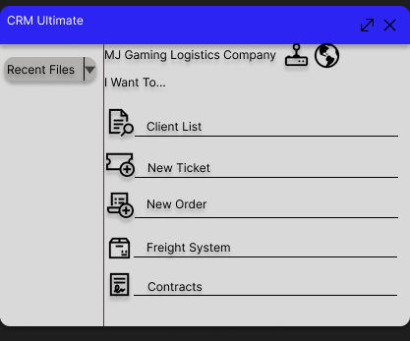

Representation 2
Lambda Technologies has provided a UML diagram in order to further represent how the CRM workflow will work as an all-in-one simplified application.
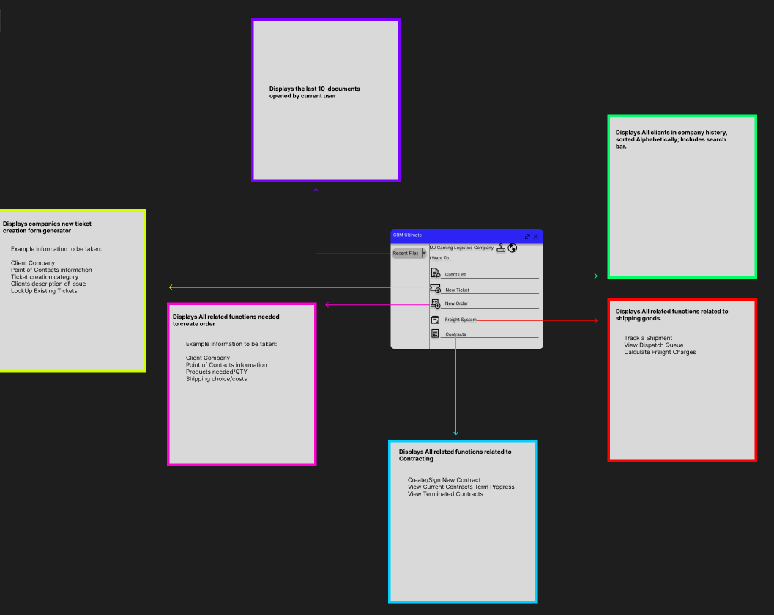

Testing

Test Name 1
Requirement to be tested:
Ticket Creation Test

Preconditions:
GUI Setup
Ticket Form Imported into Database
Data entry screen exists

Steps: The steps the tester must execute to test the feature.
- Open CRM Ultimate
- Click on Ticket Function
- Enter information in all fields to test all data porting
- Confirm ticket created screen pops up after form completion
- Check if ticket No. exists in system
- Ensure All information is listed in the proper section correctly
Expected results:
After completing the ticket creation form, a confirmation screen should pop up after a brief period of the system recording specified information for use in ticket creation. After the confirmation screen appears, the ticket should be searchable with all the entered information placed properly in the database for reference at any time.

Pass/Fail:

Passing Result:
The information entered in the ticket creation screen has been sent into the database. After the database confirms all data has been sent to itself properly, and now exits in the system, the ticket creation confirmed screen should pop up, with the ability to search for an updated ticket as needed.

Failed Result:
Some inconsistency has occurred to an unacceptable degree, such as a failure to create a ticket screen popping up after entering ticket creation and a confirmation page popping up. Still, data is not searchable at all/is not organized properly in the system. Another big failure would be that the ticket creation form does not show at all after using the GUI to navigate towards said form.

Test Name 2
Requirement to be tested:
Contract Term Tracking

Preconditions:
Contract generation must be possible
All participating parties must sign the contract
The contract terms were reviewed and approved by all necessary authorities

Steps:
- Navigate to “Contracts” in CRM Ultimate
- Click on View Contract Terms
- Enter the Contract Confirmation Code
- Ensure Correct data matches and that term progress data is displayed

Expected results:
After Entering Contract Confirmation credentials, the program should now run its course by searching the database for a matching result. Once a matching result has been found, the contract will load a digital copy of all contract terms, as well as a “quick look.” display at the top of the window notifying the current user of contract details such as time left in the contract, units sent, prices agreed upon, and more.

Pass/Fail:
Passing Result:
A test shall be noted as a pass if all expected results come true. That means the contract exists and is located with its corresponding credentials, the contract loads, the “quick look” feature is working, and the data matches with corresponding contract terms.

Failed Result:
A test shall be noted as a failure if at least one of the expected results does not happen on an unacceptable level. This can include, but not be limited to, confirmation credentials not being searchable in the system (when said credentials do exist), confirmation credentials do match in the system, but the contract does not load, or an incorrect contract loads or that “quick look” feature fails to match correct terms within the existing contract on screen.

Test Name 3
Requirement to be tested:
Freight System Tracker

Preconditions:
Freight System Center is present in the CRM program
Order Tracker option is present
The database system is ready for the storage and retrieval of freight information

Steps:
- Open CRM Ultimate and Navigate to “Freight System”
- Once there, click on “Track a Shipment.”
- From here, the user will be prompted to enter the Order Number or Tracking Information
- A new screen shall pop up momentarily to display results if the information matches the system
- Check if all information matches with database/physical copies of order status

Expected results:
Once appropriate credentials for tracking or order numbers are entered into the system; the system will attempt to find the stored data associated with the credentials. Associated orders, including invoices and parts picked or missed, will be displayed if incomplete. If the order is complete, a shipment queue will be displayed, also displaying when the shipping/receiving department is scheduled to ship orders. If shipped, all the above, plus an additional section that displays transit status as updated by the shipping partner.

Pass/Fail:
Passing Result:
A test shall be marked as a pass if all expected results occur. That is, a correct set of credentials is entered, the correct order is pulled, the information pulled is the most up-to-date, and if a tracking number is associated at the time of the test, the correct tracking number is provided and updated.

Failing Result:
A test shall be marked as a failure that does not happen on an unacceptable level. This can include but is not limited to: valid credentials returning no results, valid credentials displaying the wrong order, and updated information not applying after an excessive time period( at least 12 hours after the action has been updated in the system by the delivery partner).

